VAST
Uniform Order Form

Email form to: vasttfcc@gmail.com
Payments: Cash App Coach Adia $agfg2004 Venmo Adia-Armstrong-1
Orders are due NO LATER than the 28th of each Month until June.

Athlete(s) Name:
Parent Name:
Phone #:

Separate Items available for purchase

 | Price |  |  | ITEMS LIST
$36 |  |  | Uniform Set (top and Bottom)
$32 |  |  | Backpack
$26 |  |  | Long tights
$54 |  |  | Warm up set
$22 |  |  | Dry Fit Polo  (Unisex sizes for adults)
$18 |  |  | V-Neck Dry Fit Team-Shirt  (Unisex sizes for adults)
$9 |  |  | Arm Sleeves
$9 |  |  | Headband

Each membership includes: Backpack
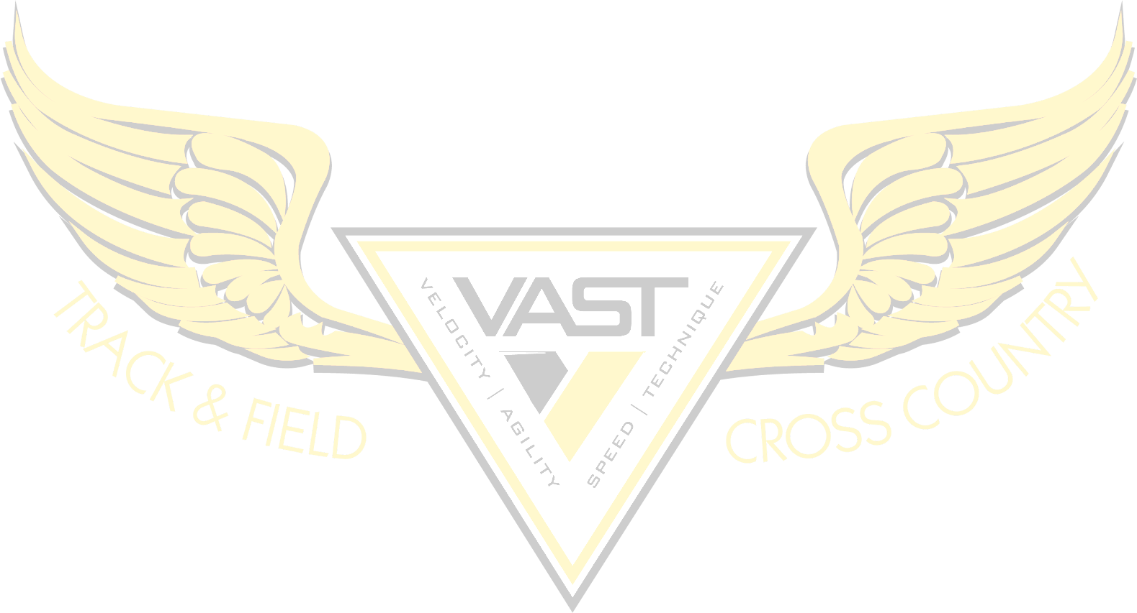
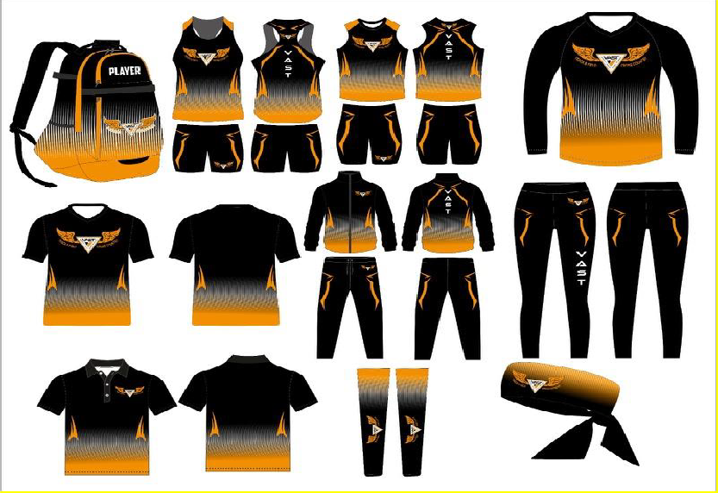
Uniform set
PLEASE NOTE:
*No mix Matched sets
**Smallest available size is Youth 3x small
***Sizes A2X and up is an additional $2 per item excluding uniform tops. All adult sizes are unisex.

Items | Size (YXS-A2x) | Name Backpacks and Warm Up Set | Item Price

Total Amount: $__________

